Name: _________________________ The Outsiders
Novel Study Booklet
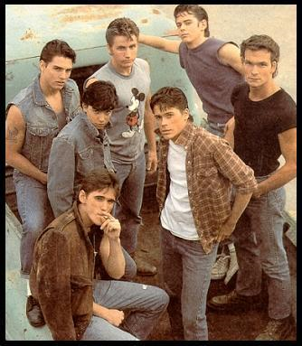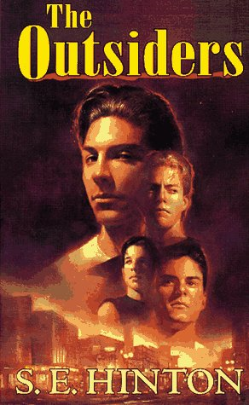
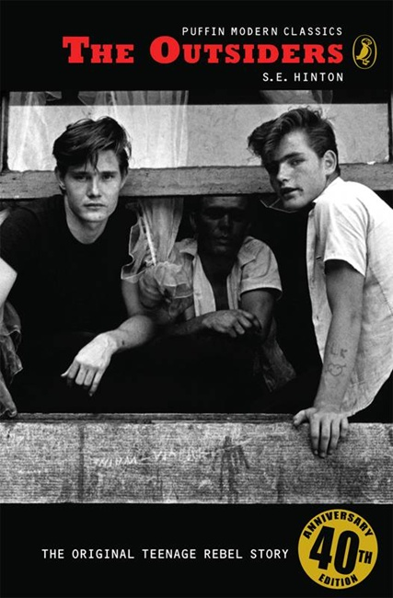 S.E. Hinton

Chapter 1
- Use the following chart to list the character traits of Greasers and Socs. Be sure to use specific words and phrases from the novel.
Greasers | Socs

- Explain how the Greasers and Socs get along.

- Using the following charts, describe the characters listed in the boxes below. You should explain what they look like, how they act, what their reputations are, etc. Be sure to use specific words and phrases from the novel.
Ponyboy

Darry

Sodapop

Steve Randle

Two-Bit Matthews

Dallas Winston (Dally)

Johnny Cade

- What is the difference between “tough” and “tuff”?

- Do YOU think that Darry loves Pony? Explain your answer.

Chapter 2
- Johnny acts very out of character during this chapter. Use the following chart to contrast Johnny’s usual behaviour with his actions in Chapter 2.
Johnny’s usual character | Johnny’s Actions in Chapter 2

2.What is a Greaser’s definition of friendship?

3.What is a Greaser’s definition of a fair fight?

4.According to Two-Bit, why don’t Socs fight fair?

5.What two rules do all Greasers follow?

Chapter 3
1.In this chapter, it becomes clear that many of the characters have dreams that they know will probably never come true. For each of the characters listed below, explain (in detail) what their dreams are. Then explain why their dreams will never come true.
Pony’s dream

Why it won’t come true:

Darry’s Dream

Why it won’t come true:

Dally’s dream

Why it won’t come true

Cherry’s dream

Why it won’t come true

Soda’s dream

Why it won’t come true

2.What request does Cherry make to Ponyboy? Are you surprised by this?

3.Why does Darry strike Ponyboy? Do you think he means to? How does he feel afterwards?

4.The blue Mustang is a symbol (an object that represents one or more ideas). What do you think the blue Mustang symbolizes? Explain.

Chapter 4
1.If you were Johnny and Pony’s lawyer, how would you defend them in a court of law? (Give THREE reasons for your defence).
a.

b.

c.

2.The boys immediately turn to Dally for help. Why is Dally the logical choice?

3.The theme of friendship is very important to this chapter. List 5 things from this chapter that reflect this theme.
a.

b.

c.

d.

e.

4.List as many ways as you can that Dally helps Pony and Johnny in this chapter.

Chapter 5
1.Pony‟s life in the city and his new life in the country differ greatly. List the differences in the
following chart, using specific details from the novel:
Pony’s life as a greaser in the city | Pony’s life at Jay Mountain

2.Put yourself in Pony’s place. How would you feel about your situation? Explain your answer in detail!

3.Answer the following questions to explain why appearance is very important in this chapter.
a.How do Pony and Johnny’s appearances change?

b.How do Ponyboy and Johnny feel about this change?

c.How will others view them now that they have changed appearances?

4.What gift does Johnny bring Pony? Why does Johnny end up enjoying this gift just as much as Pony?

5.What does the poem on page 77 mean?

6.Briefly describe what life is now like in the city for the Greasers and the Socs. Use specific details from the novel in your response.

Chapter 6
Each of the following quotations from this chapter are important. They give the reader a better understanding of the characters referred to by the quotation. Explain why the quotations are important. What do they tell you about the characters being mentioned? How do they improve your understanding?

1. “...I said we're goin' back to turn ourselves in...”

2.”...Oh, blast it, Johnny”–he pushed his white-blond hair back out of his eyes
–“you get hardened in jail. I don't want that to happen to you. Like it happened to me…”

3. “I caught one quick look at his face; it was red-marked from falling embers and sweat-streaked, but he grinned at me. He wasn't scared either. That was the only time I can think of when I saw him without that defeated, suspicious look in his eyes. He looked like he was having the time of his life.”

4. “I had taken the long way around, but I was finally home. To stay.”

Chapter 7
1.One of the major topics of chapter 7 is that “things are rough all over.” Using a Venn diagram below, list the following:
a.things that are rough for the Greasers
b.things that are rough for the Socs
c.things that are rough for both the Greasers and the Socs

2.What do you think the relationship between Pony and Darry will be like now? Give some specific examples from Chapter 7 of how their relationship is already changing.

3.Describe Johnny's medical condition.

4.Do you think the Curtis Brothers will be separated? Explain your answer.

5.What has happened to Sandy? How does Soda feel about the situation?

Chapter 8
1.Describe Johnny’s attitude towards death.

2.Use the following chart to compare Johnny's feeling for his family before he is in the hospital to his feelings after he is in the hospital.
Before Accident | After Hospitalization

3.Why do you think that Johnny’s feelings about his parents change?

4.What does Dally ask Two-Bit for? What do you think that he will do with it?

5.How does Pony feel about Cherry Valance right now? Use a specific example from the book to support your answer.

Chapter 9
1.The rumble allows Pony to be proud to be a Greaser, even though he does not like many of the things that Greasers do. Explain this contradiction.

2.How do the boys act before the rumble? Give specific examples. Explain why they act this way.

3.Pony asks everyone in the gang why they like to fight. Fill in the chart below using this information.
Soda

Steve

Darry

Two-Bit

Pony

4.Why does Darry hate Paul Holden so much?

5.List at least 5 things that happen in the rumble.
A.

B.

C.

D.

E.

6.What are Johnny’s last words? What do you think they mean?

Chapters 10, 11 , and 12
1.For each of the following causes, list several effects that result from the incident.
Cause Effect

Cause Effect

Cause Effect

- There is evidence that the relationship between Pony and Darry is improving. Give at least TWO examples from these three chapters that support this idea.

3.In the book, the judge makes a decision to let the family stay together. If you were that judge, would you have removed Pony and placed him in foster care, or would you have let the family stay together? Explain your answer.

4.The letter that Johnny writes to Pony has a very strong effect on him. How does it change Pony’s attitude and behaviour?

5.Now that you have finished reading the book, would you recommend it to others? Why or why not?

